# Release #1

## Website Design Ideas:

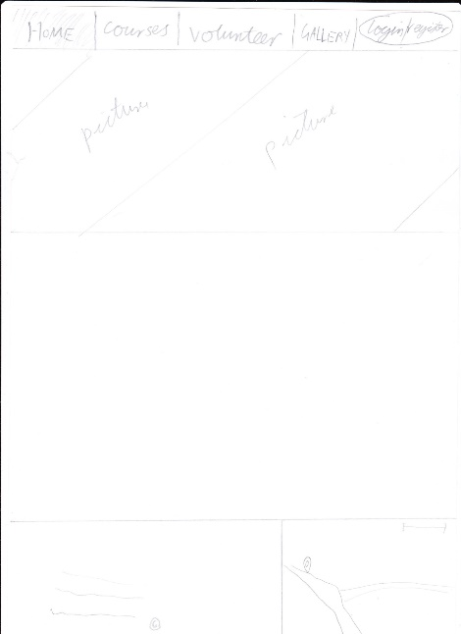During Release 1 there were a number of different ideas about what we wanted the website to look like I drew up a few different ideas for the website to allow a number of different ideas to be trialed before a final idea was chosen between the group. 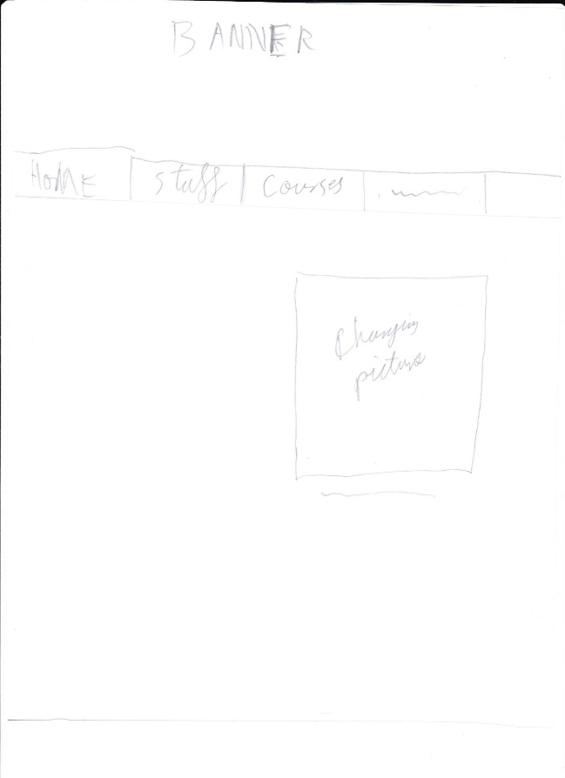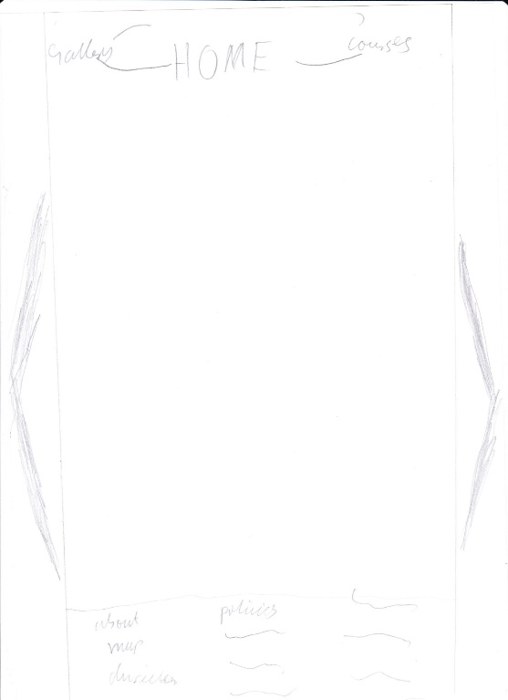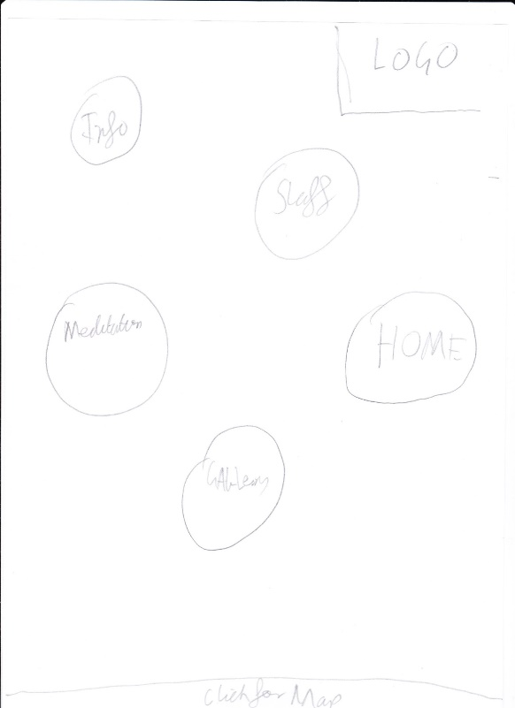

## Template Design

The next thing we decided on was finding a template to be able to use both Geo and I searched multiple websites for website templates to try and find a template that suited our websites needs. This would allow for a professional looking website without the hassle of designing too much and focus on the backend of the website. In the end a website to do with biopharming was chosen. The website template was then edited to suit our needs removing unnecessary features off the template and fixing other small features to better improve the functionality to do with the meditation task.

## Profile Page

The profile page design was done to accommodate for all information from the signup page this allows a user to edit their profile for future reference. As well as, this allowing for if they can be a server or not was added giving an easy to view display whether or not they can be a server. Edit profile was also added to be able to easily edit the sql database without the need of an admin. The information entered was decided by me and Chee Ho did the php to send the data to the website allowing for the information to be viewed by the servers or students.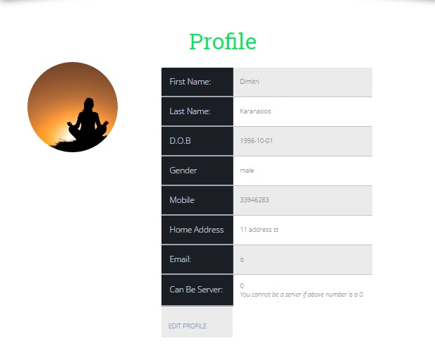

## Admin Accounts

The admin accounts were given a different set of buttons to be able to edit courses of different users in the meditation Centre. This allowing the ease of deletion if someone needed to cancel a booking over the phone as well as this server bookings and messages can also be displayed within this admin panel. This also meant that admin accounts needed different permissions to allow for the access of different website URL’s

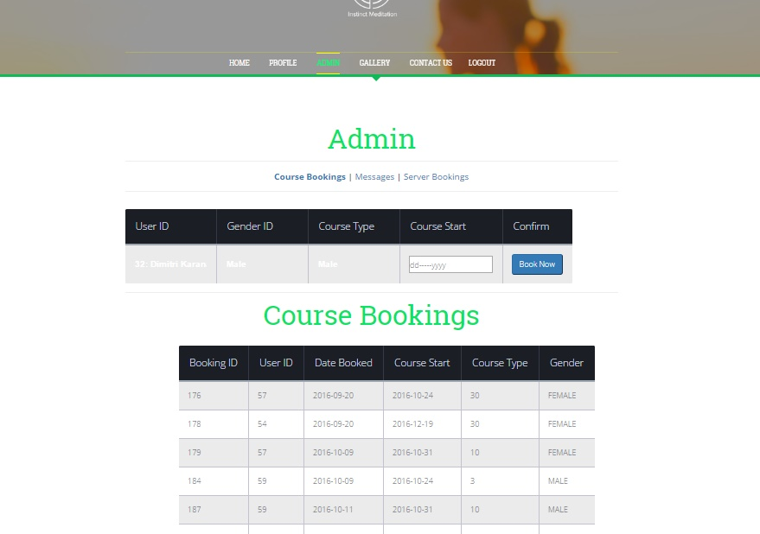

## Database Tables

Dimitri got me to setup relevant database tables for him to be able to input data to different parts of the website including User input, course bookings, server bookings and messages. This allowed him to concentrate on different parts of the website and have the database already setup for the php. The tables can be shown below.

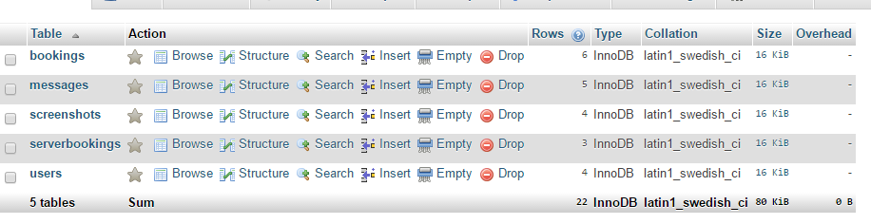

# Release #2

## Admin panel fix

The admin panel started off as a single page consisting of all the information needed but then I suggested to have the whole page split into three subpages allowing for the admins to easily navigate between information.



## Website Testing

Website testing was performed by Jon, Chee and I. This involved going over all the different user stories that had been written up and checking if each user story and every feature could actually be used. This allowed for Dimitri and mitch to find the main bugs and fix them within the backend website. I also assisted Dimitri with the bug fixes within the website and the backend. The main bugs

## Second burndown chart

During the second release I helped create the burndown chart and made sure we stuck to the outlined times that had been selected for our group. We were able to directly stay on the burndown chart line and made sure since not many features needed to be added to stay directly on task. This meant the burndown chart looked as if we didn’t finish it but really the line is directly behind.

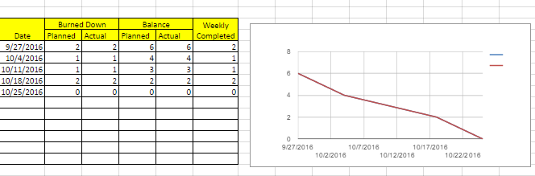

## Code Cleanup

Dimitri and I went through the code before final release to make the code easier to read this allows for if other website developers were to look through the code it would be easy to read. This also meant for future releases finding and editing old code would be easier. The main code cleanup was fixing styling, formatting and adding code comments.

